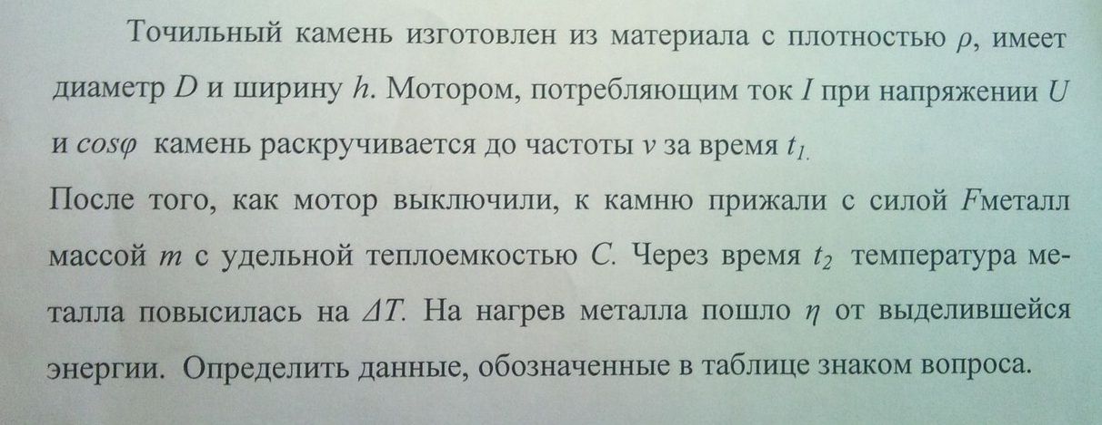
ρ | D | h | I | U | cosφ | ν | t₁ | F | m | C | t₂ | ∆T | η
? | 0,28 | 0,03 | 2 | 220 | 0,6 | 50 | 1,5 | ? | 0,5 | 500 | 2 | ? | 0,35

